
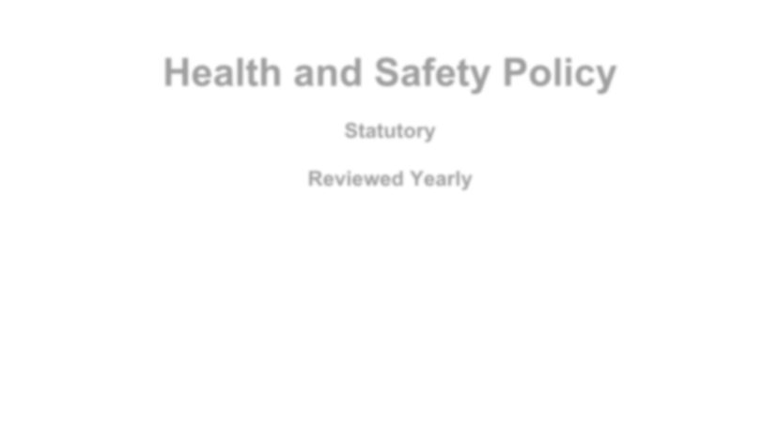
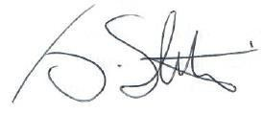









Health and Safety Policy

Statutory Reviewed Yearly

Signed: (Chair of the Trust) Date: November 2025
Review Date: November 2026

Section A – Statement of Intent

1. General Policy Statement

This policy is based on advice from the Department for Education on health and safety in schools and the following legislation:
- The Health and Safety at Work etc. Act 1974, which sets out the general duties employers have towards employees and duties relating to lettings
- The Management of Health and Safety at Work Regulations 1992, which require employers to make an assessment of the risks to the health and safety of their employees
- The Management of Health and Safety at Work Regulations 1999, which require employers to carry out risk assessments, make arrangements to implement necessary measures, and arrange for appropriate information and training
- The Control of Substances Hazardous to Health Regulations 2002, which require employers to control substances that are hazardous to health
- The Reporting of Injuries, Diseases and Dangerous Occurrences Regulations (RIDDOR) 2013, which state that some accidents must be reported to the Health and Safety Executive and set out the timeframe for this and how long records of such accidents must be kept
- The Health and Safety (Display Screen Equipment) Regulations 1992, which require employers to carry out digital screen equipment assessments and states users’ entitlement to an eyesight test
- The Gas Safety (Installation and Use) Regulations 1998, which require work on gas fittings to be carried out by someone on the Gas Safe Register
- The Regulatory Reform (Fire Safety) Order 2005, which requires employers to take general fire precautions to ensure the safety of their staff
- The Work at Height Regulations 2005, which requires employers to protect their staff from falls from height
The school follows national guidance published by Public Health England when responding to infection control issues.

This policy complies with our funding agreement and articles of association.

2 Health and Safety Policy

Section B - Organisation
- Local Advisory Board Roles and Responsibilities

The Trust board has ultimate responsibility for health and safety matters in the school, but will delegate day-to-day responsibility to the Headteacher who will ensure:

  - That arrangement exists for the school to comply with its Health and Safety responsibilities.

  - That the School Leadership Team adopts reviews periodically and amends, as appropriate, the School Health and Safety Policy in line with the Children’s Services and Corporate Health and Safety Policy.

  - That adequate funds and materials required to meet all statutory and Council’s Health and Safety requirements are budgeted for.

  - That periodic monitoring inspection is carried out to maintain and enhance the school safety performance.

  - The effectiveness of the policy is periodically appraised and any necessary changes made.

  - They take a direct interest in the policy and publicly support all those carrying it out.

The Trust has a duty to take reasonable steps to ensure that staff and pupils are not exposed to risks to their health and safety. This applies to activities on or off the school premises.
The Trust as as the employer, also has a duty to:
    - Assess the risks to staff and others affected by school activities in order to identify and introduce the health and safety measures necessary to manage those risks
    - Inform employees about risks and the measures in place to manage them
    - Ensure that adequate health and safety training is provided

Headteacher Roles and Responsibilities

The Headteacher in each of the Trust Schools is accountable to Trustees for implementing and monitoring the Schools Health and Safety Policy by:

  - Ensuring that responsibility is assigned and accepted at all subordinate levels.

www.rivermeadinclusivetrust.co.uk 3

  - Taking day-to-day responsibility for all health and safety matters in the school.

  - Liaising with the LAB and Rivermead Inclusive Trust via the facilities manager (Mr Warren Lovey) on policy issues.

  - Ensuring that staff have sufficient information, instruction, training and supervision to enable them to comply with departmental safe systems of work, established rules and working practices.

  - Appointing a senior member of staff within each KS to co-ordinate health and safety matters affecting their area.
  - Implementing the health and safety policy

  - Ensuring there is enough staff to safely supervise pupils

  - Ensuring that the school building and premises are safe and regularly inspected

  - Reporting to the governing board/ Trust on health and safety matters

  - Ensuring appropriate evacuation procedures are in place and regular fire drills are held

  - Ensuring that in their absence, health and safety responsibilities are delegated to another member of staff

  - Ensuring all risk assessments are completed and reviewed

  - Monitoring cleaning contracts, and ensuring cleaners are appropriately trained and have access to personal protective equipment, where necessary

In the Headteacher’s absence, the Deputy Headteacher assumes the above day-to-day health and safety responsibilities.

Senior Staff Responsibilities

Senior Staff are accountable to their Headteacher for implementing the schools health and safety policy, rules, procedures and working practices by:

  - Ensuring that where unsafe working practices or unsafe conditions are identified then remedial measures to eliminate or reduce the hazards are introduced.

4 Health and Safety Policy

  - Ensuring that safe systems of work are being adhered to within their operational area.

  - Ensuring that temporary or new staff are fully instructed on all aspects of safe working within their area of control.

  - Ensuring that all accidents, incidents and near misses are fully investigated, recorded, reported under the Reporting of Injuries and Dangerous Occurrences Regulations 1995 where appropriate and remedial action implemented.

Staff Responsibilities

Members of staff are responsible and accountable to maintain a safe area of work by:

  - Ensuring that classrooms / work areas are safe.

  - Ensuring that all equipment and materials are safe before use.

  - Ensuring safe procedures are followed.

  - Ensuring that protective equipment is used when required.

  - Complying with the school’s safety policy at all time.

  - Reporting all health and safety hazards to senior members of staff.

  - Take reasonable care of their own health and safety and that of others who may be affected by what they do at work

Trade Union Representatives Responsibilities

Trade Union Representatives are appointed by their Trade Unions, or elected by their colleagues, to develop (together with the School Management Team) safe working practices, to promote and monitor these measures, to ensure their effectiveness. Their role encompasses the investigation of health and safety-related complaints and identification and reporting on all matters relating to health and safety in schools.

www.rivermeadinclusivetrust.co.uk 5

Pupils Responsibilities

Pupils have a duty to take reasonable care of themselves and others and to co-operate in the implementation of the School Health and Safety Policy by:

  - Complying with the school’s safety rules and requirements at all times.

  - Complying with safety instructions given by members of staff.

  - Wearing the protective equipment provided and making proper use of safety devices at all times.

  - Reporting all safety hazards to members of staff.

  - Reporting all accidents, incidents and near misses to members of staff

Parents’ Responsibilities

Parents are responsible for following the school’s health and safety advice, on-site and off-site, and for reporting any health and safety incidents to a member of staff.

Monitoring and Review
This policy will be monitored by the LAB and reviewed annually by the Finance, Audit and Risk Committee.

6 Health and Safety Policy

Section C - Arrangements

- General Practices Applying to all Staff, Pupils and Visitors

The Rivermead Inclusive Trust is committed to the implementation of policies, procedures and arrangements for safety as detailed in the individual schools Health and Safety Manual as produced by ‘Risk Services’, Safety Arrangements, which is not exhaustive but includes the following:

  - Fire Evacuation Procedures
  - Bomb Alert Procedures
  - First Aid Arrangements
  - Accident Reporting and Recording Procedures
  - Risk Management Procedures
  - Manual Handling Arrangements
  - Administration of Medicines / Medical Treatment to Pupils
  - Blood Spillage Procedure
  - Playground Safety
  - The Working Environment
  - Control and Monitoring of Contractors
  - New and Expectant Mothers
  - Display Screen Equipment
  - Plant and Equipment Safety
  - Control of Substances Hazardous to Health 1995
  - No Smoking Policy
  - Lone Working Procedures

School Specific Arrangements

  - School Transport – Mini Buses
  - Science Labs
  - Technology Labs
  - Transport of Cash
  - Physical Education and Games
  - Alcohol, Drug and Solvent Abuse
  - School Trips / Educational/Offsite Activities
  - School Security
  - Violence & Aggressive Behaviour Towards Staff
  - Letting of School Property to Outside Bodies

www.rivermeadinclusivetrust.co.uk 7

  - Vehicle Movement on School Property
  - Work Experience Arrangements
  - Jewellery in Schools
  - Sun Safety
  - Temperatures in Classrooms
  - Safety Policy Review Procedure

8 Health and Safety Policy

