Mental Health Wellbeing (MHWB) Term 5 Edition 1



Welcome to the Mental Health Wellbeing Newsletter!
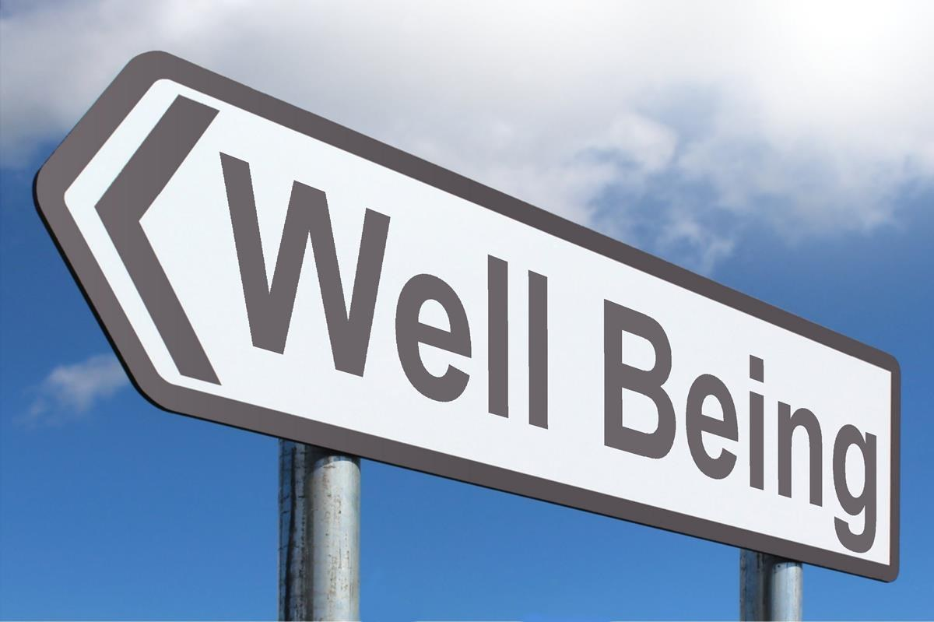
In this edition you will find:
- Information about Borderline Personality Disorder
- This term we shine the light on Walderslade's new therapy room
- Helpful resources for helping our children regulate their breathing

Borderline Personality Disorder
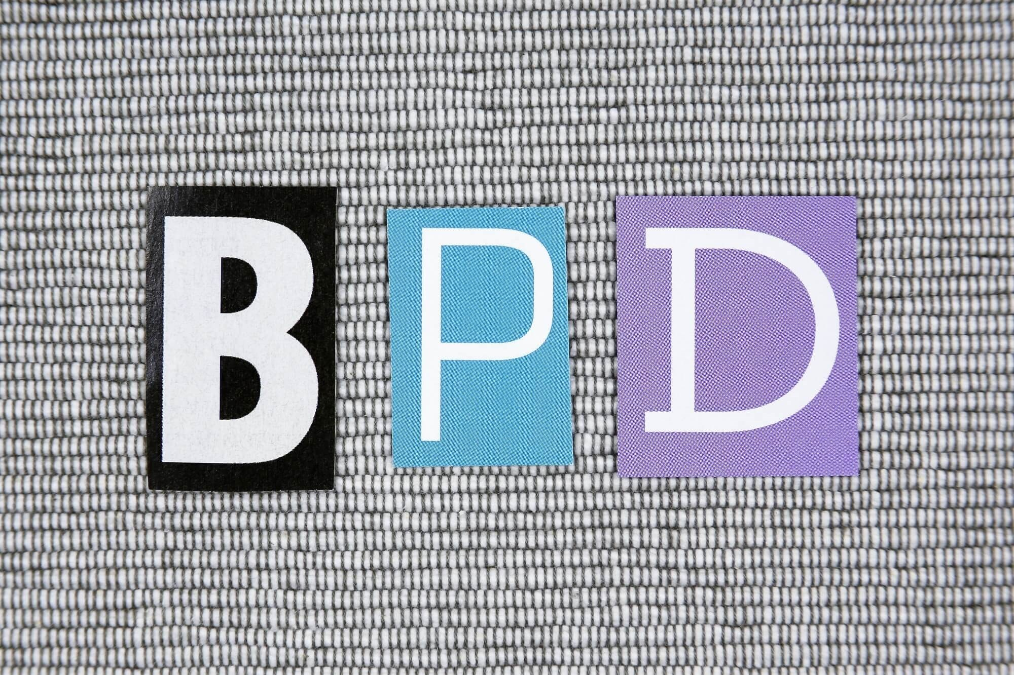

Borderline personality disorder (BPD) is a type of personality disorder.
You might be diagnosed with a personality disorder if you have difficulties with how you think and feel about yourself and other people, and are having problems in your life as a result.
When is BPD diagnosed?
You might be given a diagnosis of BPD if you experience at least five of the following things, and they've lasted for a long time or have a big impact on your daily life:
- You feel very worried about people abandoning you, and would do anything to stop that happening.
- You have very intense emotions that last from a few hours to a few days and can change quickly (for example, from feeling very happy and confident to suddenly feeling low and sad).
- You don't have a strong sense of who you are, and it can change significantly depending on who you're with.
- You find it very hard to make and keep stable relationships.
- You feel empty a lot of the time.
- You act impulsively and do things that could harm you (such as binge eating, using drugs or driving dangerously).
- You often self-harm or have suicidal feelings.
- You have very intense feelings of anger, which are really difficult to control.
- When very stressed, you may also experience paranoia or dissociation.
Because you only need to experience five of these difficulties to be given a diagnosis of BPD, it can be a very broad diagnosis which includes lots of different people with very different experiences.
Some people find it helpful to have a diagnosis because they feel it explains and helps people to understand their difficulties, or gives them a sense of relief and validation.
Others feel their diagnosis isn't helpful, disagreeing entirely with the current system of diagnosing personality disorders and finding it stigmatising and unhelpful. For example, some people prefer not to describe their experiences as medical problems, or would rather see them as a response to difficult life events.

Walderslade's Therapy Room
At Walderslade they have been developing the space their learners take part in ELSA and Play Therapy. The school have tried to support their learners by offering additional counsellor time allocated. Their learners have individual MHWB plans in place that have helped support pupil transition during Covid-19. Walderslade's PSHE curriculum looks after developing their children's MHWB skills and knowledge and they currently use the JIGSAW Programme across the school to embed this.
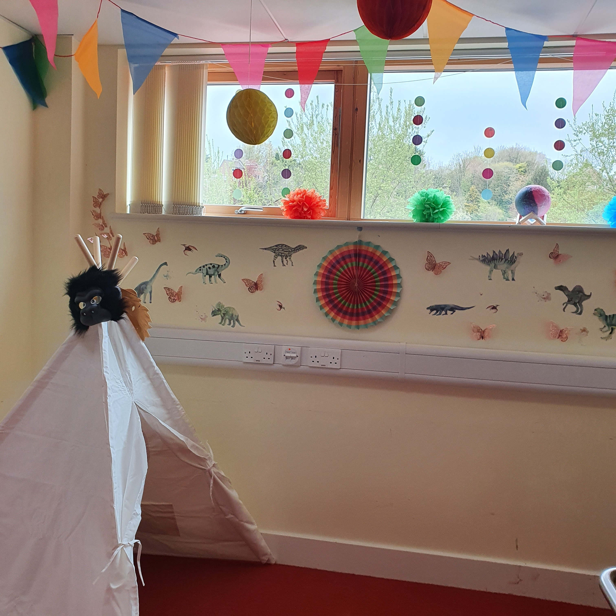
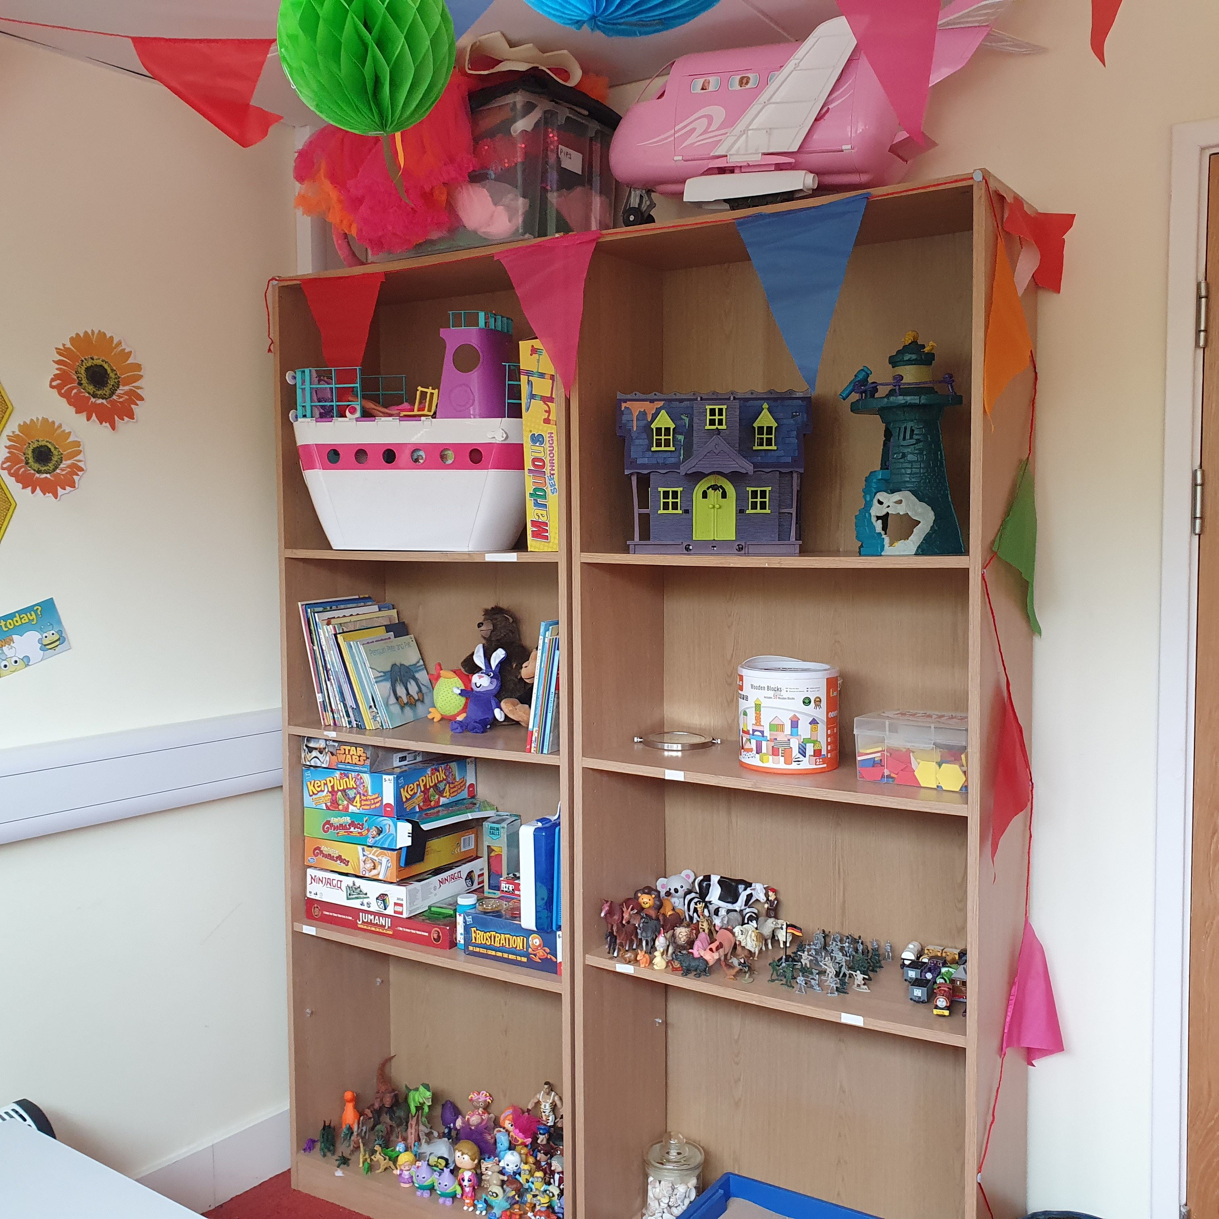
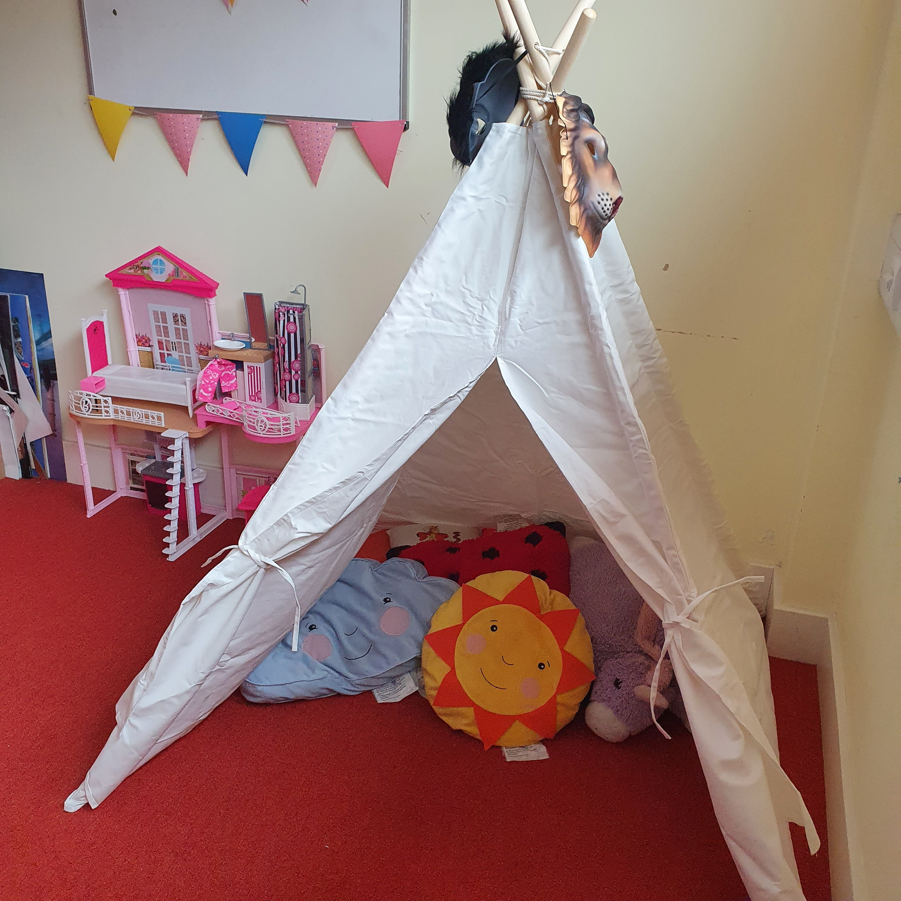
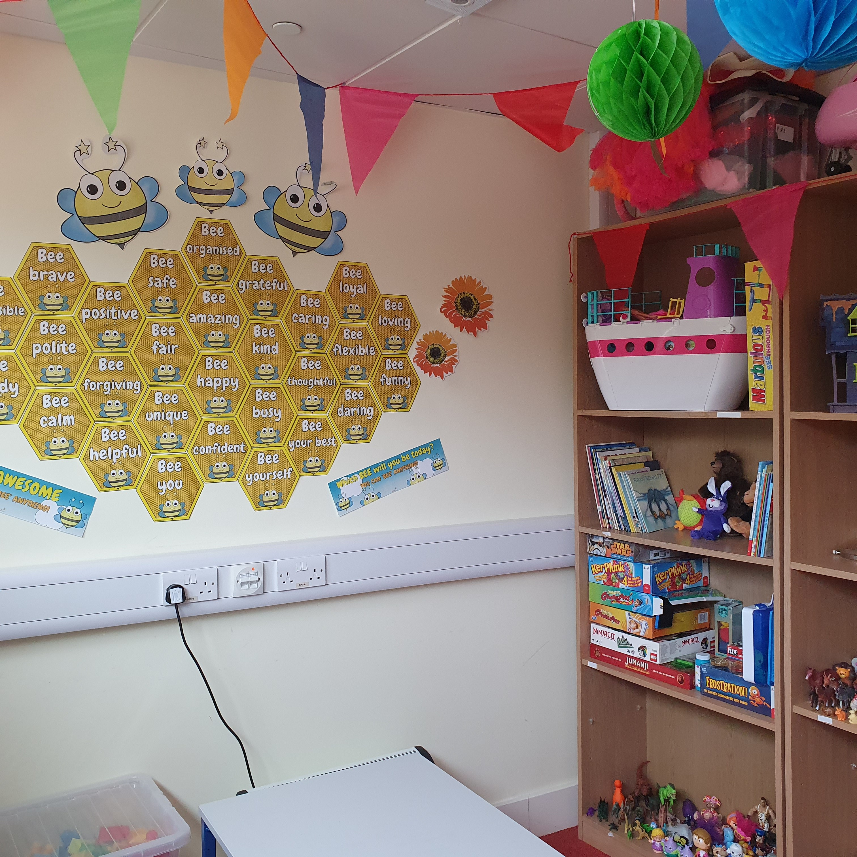

Helpful Resources for helping our children to regulate their breathing

1 - If you fancy a daily yoga session with your youngster, Cosmic Kids Yoga on YouTube is amazing- she has 464 different stories to do yoga to as well as videos explaining what it means by things such as Anxiety and Mindfulness.
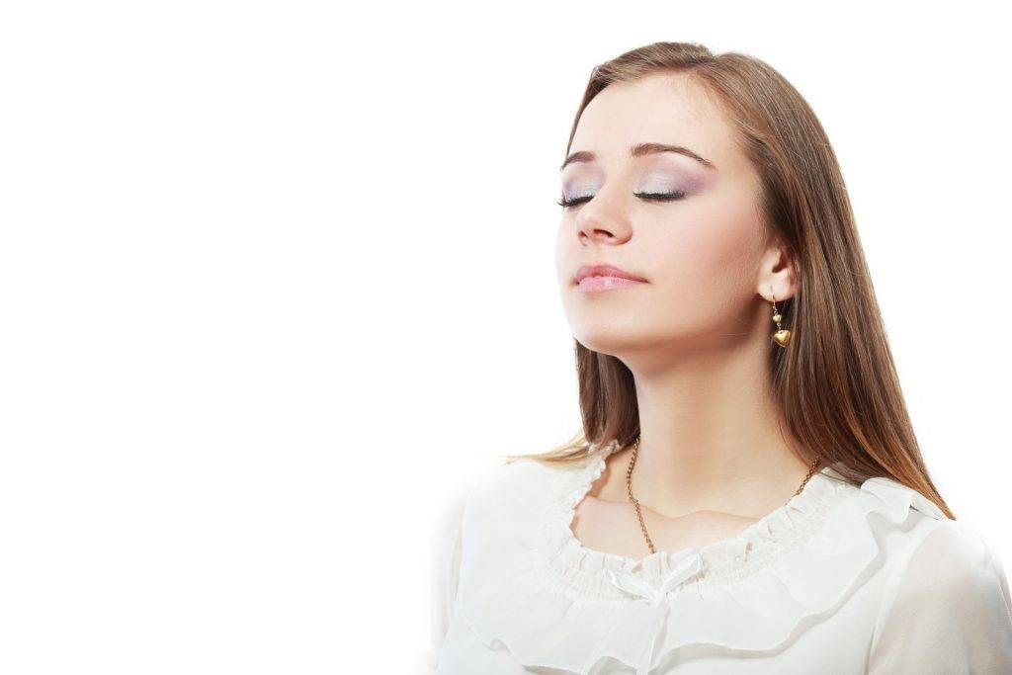
2 - Three Breathing Exercises and Techniques we rate here at the RIT Click here
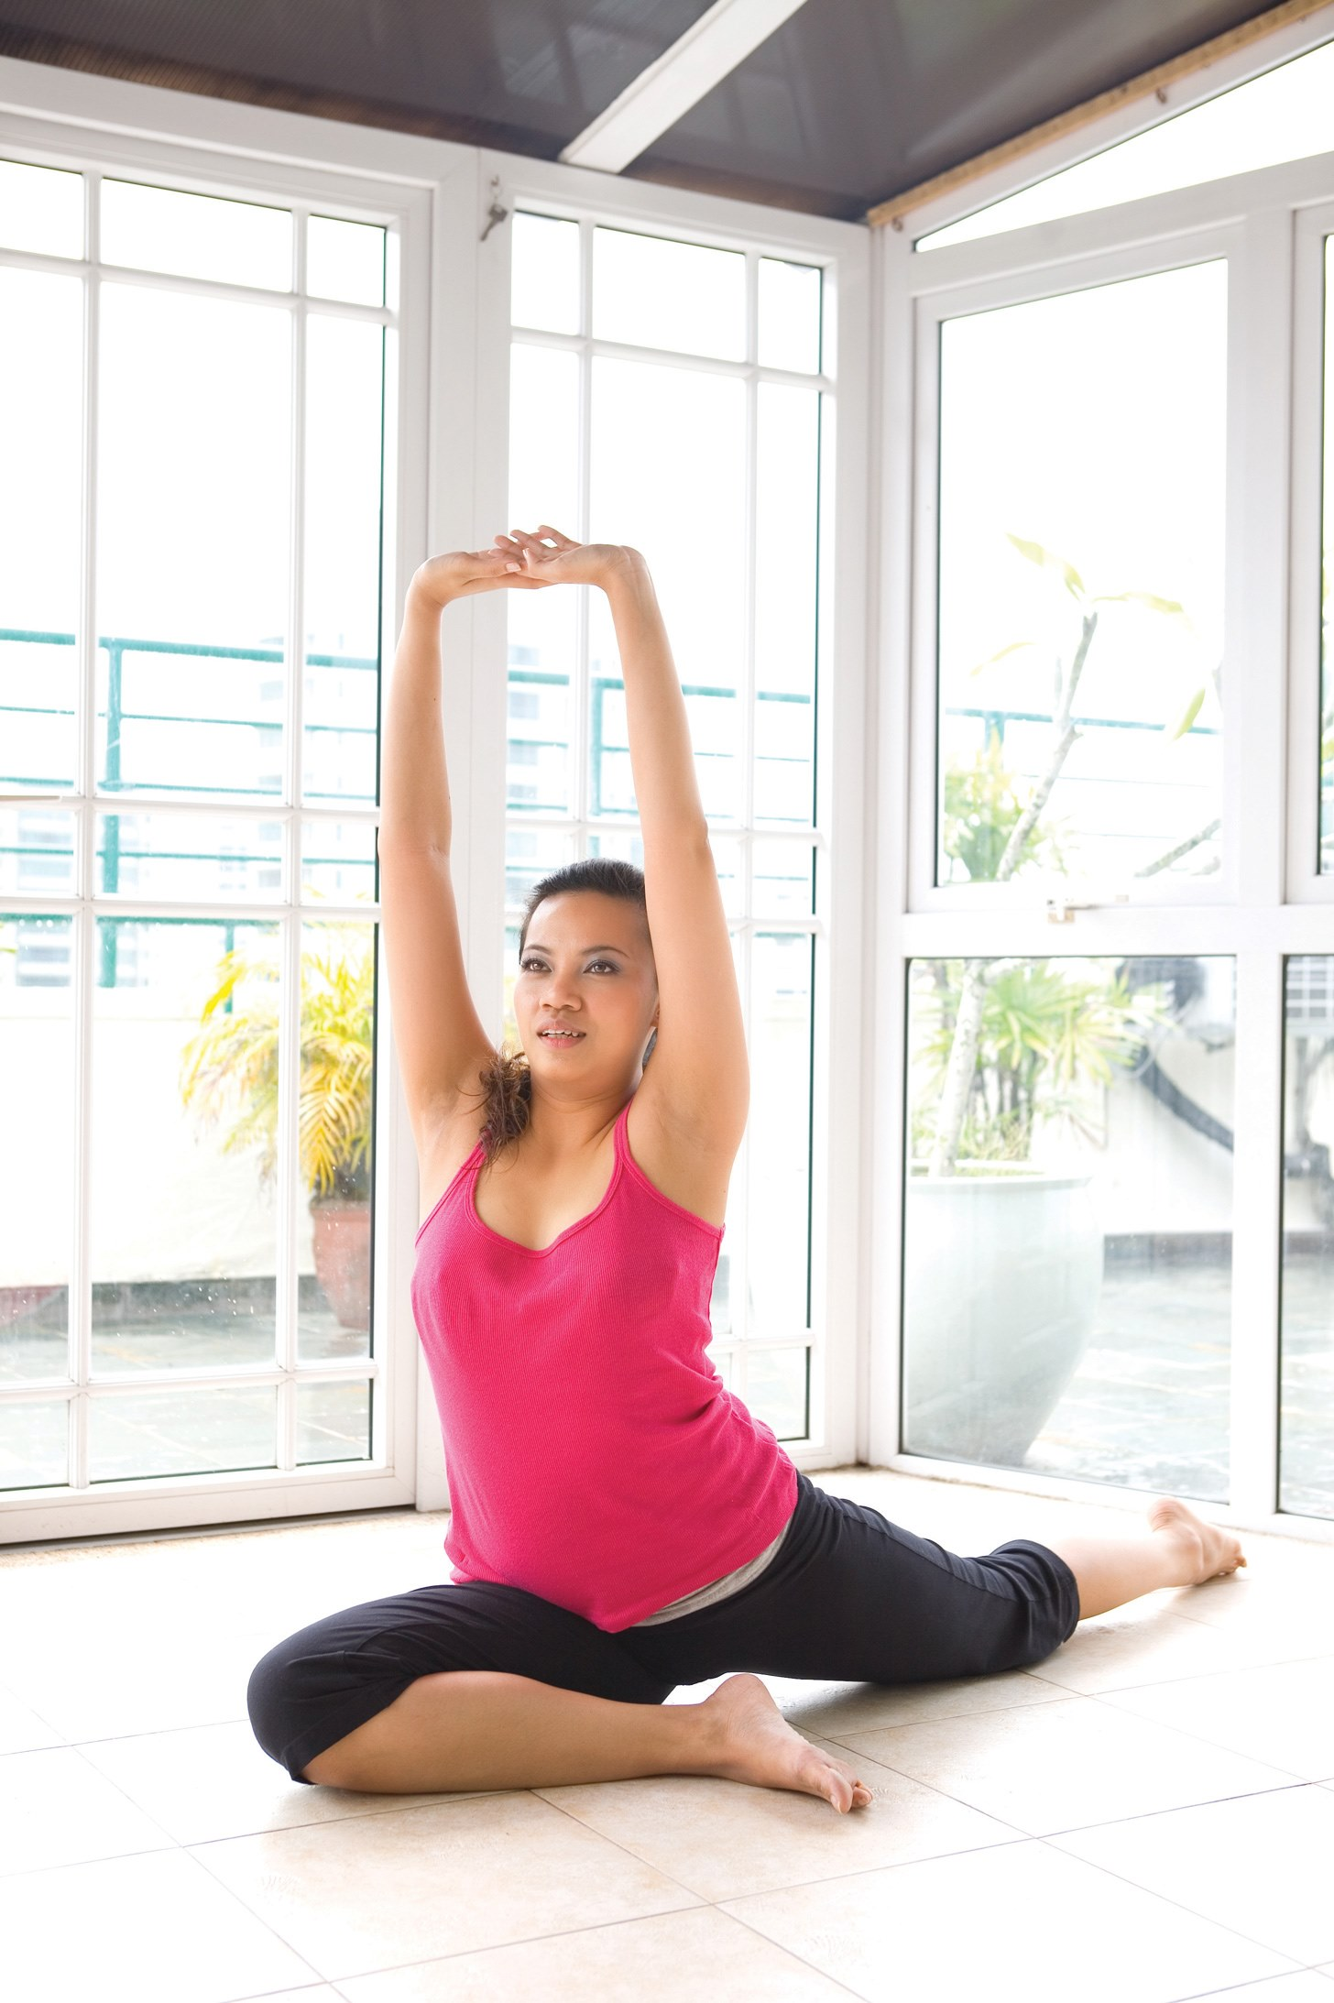
3 - Watch this video to learn a new breathing technique for the whole family. Look up other ‘Pooky Knightsmith Mental Health’ videos on Youtube for more breathing regulation techniques.

